# LeNet on CIFAR-10
# --------------------------------

import time
import numpy as np
from tqdm import tqdm
from sklearn.metrics import accuracy_score, precision_score, recall_score, f1_score
import tensorflow as tf
from tensorflow.keras import layers, models, datasets, utils

# ---- Build LeNet ----
def build_lenet(input_shape=(28, 28, 1), num_classes=10):
model = models.Sequential([
layers.Conv2D(6, (5, 5), activation='tanh', padding='same', input_shape=input_shape),
layers.AveragePooling2D(pool_size=(2, 2)),
layers.Conv2D(16, (5, 5), activation='tanh'),
layers.AveragePooling2D(pool_size=(2, 2)),
layers.Flatten(),
layers.Dense(120, activation='tanh'),
layers.Dense(84, activation='tanh'),
layers.Dense(num_classes, activation='softmax')
])
return model

# ---- Load MNIST ----
(x_train, y_train), (x_test, y_test) = datasets.mnist.load_data()
x_train = x_train.reshape(-1, 28, 28, 1) / 255.0
x_test = x_test.reshape(-1, 28, 28, 1) / 255.0
y_train = utils.to_categorical(y_train)
y_test = utils.to_categorical(y_test)

# ---- Train ----
model = build_lenet()
model.compile(optimizer='adam', loss='categorical_crossentropy', metrics=['accuracy'])

start = time.time()
for epoch in tqdm(range(10), desc="Training LeNet"):
model.fit(x_train, y_train, epochs=10, batch_size=32, verbose=0)
loss, acc = model.evaluate(x_test, y_test, verbose=0)
print(f"Epoch {epoch+1}: Accuracy={acc:.4f}, Loss={loss:.4f}")

# ---- Evaluate ----
y_pred = np.argmax(model.predict(x_test), axis=1)
y_true = np.argmax(y_test, axis=1)
print("\n✅ Final Results (LeNet):")
print(f"Accuracy: {accuracy_score(y_true, y_pred):.4f}")
print(f"Precision: {precision_score(y_true, y_pred, average='macro'):.4f}")
print(f"Recall: {recall_score(y_true, y_pred, average='macro'):.4f}")
print(f"F1: {f1_score(y_true, y_pred, average='macro'):.4f}")
print(f"Training time: {time.time() - start:.2f} sec")

model.save("lenet_model.keras")
print("💾 Model saved as lenet_model.keras")

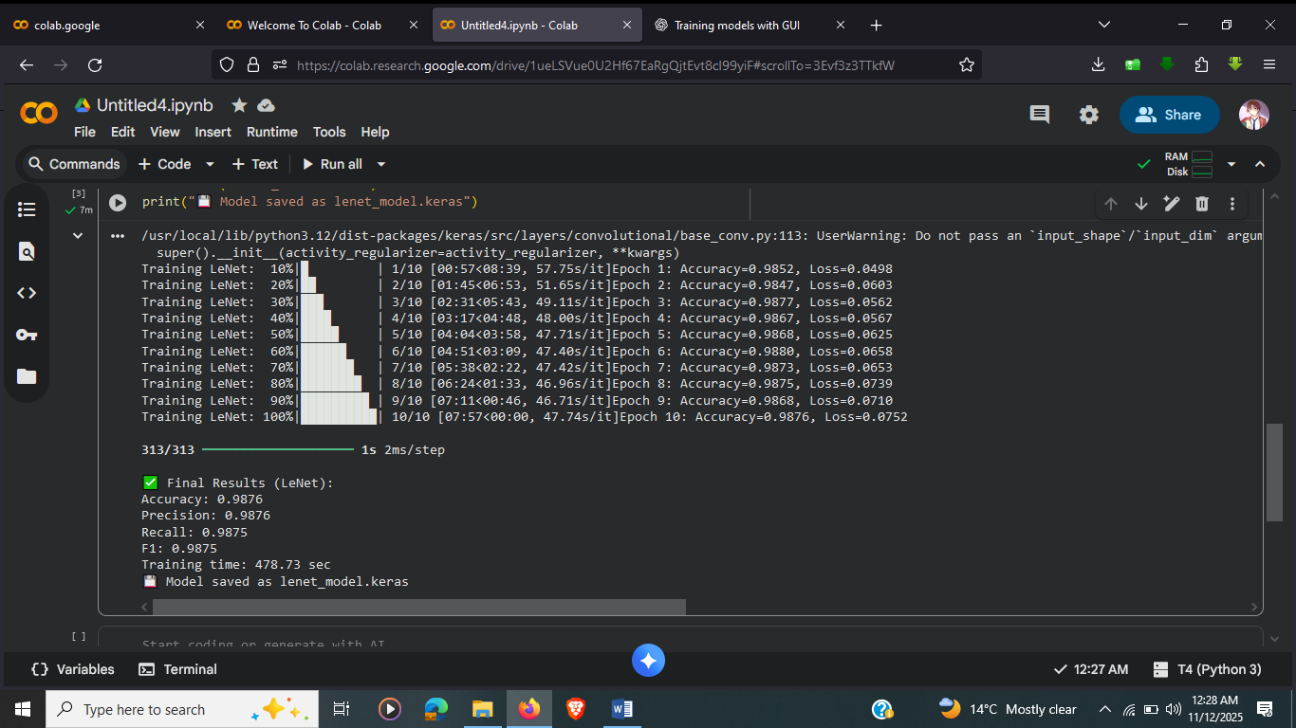

# AlexNet on CIFAR-10
# ---------------------------------
import time
import numpy as np
from tqdm import tqdm
from sklearn.metrics import accuracy_score, precision_score, recall_score, f1_score
import tensorflow as tf
from tensorflow.keras import layers, models, datasets, utils

# ---- Build AlexNet ----
def build_alexnet(input_shape=(32, 32, 3), num_classes=10):
model = models.Sequential([
layers.Conv2D(96, (3, 3), strides=1, activation='relu', input_shape=input_shape), # Adjusted kernel and strides
layers.MaxPooling2D((3, 3), strides=2),
layers.Conv2D(256, (5, 5), padding='same', activation='relu'),
layers.MaxPooling2D((3, 3), strides=2),
layers.Conv2D(384, (3, 3), padding='same', activation='relu'),
layers.Conv2D(384, (3, 3), padding='same', activation='relu'),
layers.Conv2D(256, (3, 3), padding='same', activation='relu'),
layers.MaxPooling2D((3, 3), strides=2),
layers.Flatten(),
layers.Dense(4096, activation='relu'),
layers.Dense(4096, activation='relu'),
layers.Dense(num_classes, activation='softmax')
])
return model

# ---- Load CIFAR-10 ----
(x_train, y_train), (x_test, y_test) = datasets.cifar10.load_data()
x_train = x_train.astype("float32") / 255.0
x_test = x_test.astype("float32") / 255.0
y_train = utils.to_categorical(y_train.flatten())
y_test = utils.to_categorical(y_test.flatten())

# ---- Train ----
model = build_alexnet()
model.compile(optimizer='adam', loss='categorical_crossentropy', metrics=['accuracy'])

start = time.time()
for epoch in tqdm(range(5), desc="Training AlexNet"):
model.fit(x_train, y_train, epochs=1, batch_size=64, verbose=0) # Changed epochs to 1
loss, acc = model.evaluate(x_test, y_test, verbose=0)
print(f"Epoch {epoch+1}: Accuracy={acc:.4f}, Loss={loss:.4f}")

# ---- Evaluate ----
y_pred = np.argmax(model.predict(x_test), axis=1)
y_true = np.argmax(y_test, axis=1)
print("\n✅ Final Results (AlexNet):")
print(f"Accuracy: {accuracy_score(y_true, y_pred):.4f}")
print(f"Precision: {precision_score(y_true, y_pred, average='macro'):.4f}")
print(f"Recall: {recall_score(y_true, y_pred, average='macro'):.4f}")
print(f"F1: {f1_score(y_true, y_pred, average='macro'):.4f}")
print(f"Training time: {time.time() - start:.2f} sec")

model.save("alexnet_model.keras")
print("💾 Model saved as alexnet_model.keras")

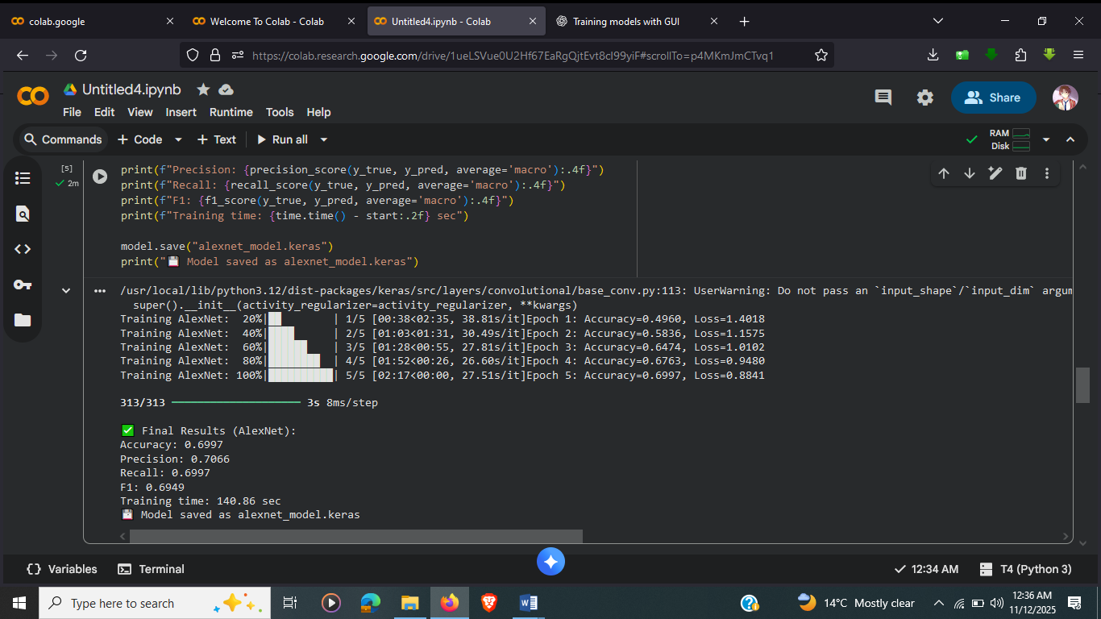

# VGGNet on CIFAR-10
# --------------------------------
import time
import numpy as np
from tqdm import tqdm
from sklearn.metrics import accuracy_score, precision_score, recall_score, f1_score
import tensorflow as tf
from tensorflow.keras import layers, models, datasets, utils

# ---- Build VGG ----
def build_vgg(input_shape=(32, 32, 3), num_classes=10):
model = models.Sequential([
layers.Conv2D(64, (3, 3), activation='relu', padding='same', input_shape=input_shape),
layers.Conv2D(64, (3, 3), activation='relu', padding='same'),
layers.MaxPooling2D((2, 2)),

layers.Conv2D(128, (3, 3), activation='relu', padding='same'),
layers.Conv2D(128, (3, 3), activation='relu', padding='same'),
layers.MaxPooling2D((2, 2)),

layers.Conv2D(256, (3, 3), activation='relu', padding='same'),
layers.Conv2D(256, (3, 3), activation='relu', padding='same'),
layers.MaxPooling2D((2, 2)),

layers.Flatten(),
layers.Dense(512, activation='relu'),
layers.Dense(num_classes, activation='softmax')
])
return model

# ---- Load CIFAR-10 ----
(x_train, y_train), (x_test, y_test) = datasets.cifar10.load_data()
x_train = x_train.astype("float32") / 255.0
x_test = x_test.astype("float32") / 255.0
y_train = utils.to_categorical(y_train.flatten())
y_test = utils.to_categorical(y_test.flatten())

# ---- Train ----
model = build_vgg()
model.compile(optimizer='adam', loss='categorical_crossentropy', metrics=['accuracy'])

start = time.time()
for epoch in tqdm(range(3), desc="Training VGGNet"):
model.fit(x_train, y_train, epochs=3, batch_size=32, verbose=0)
loss, acc = model.evaluate(x_test, y_test, verbose=0)
print(f"Epoch {epoch+1}: Accuracy={acc:.4f}, Loss={loss:.4f}")

# ---- Evaluate ----
y_pred = np.argmax(model.predict(x_test), axis=1)
y_true = np.argmax(y_test, axis=1)
print("\n✅ Final Results (VGGNet):")
print(f"Accuracy: {accuracy_score(y_true, y_pred):.4f}")
print(f"Precision: {precision_score(y_true, y_pred, average='macro'):.4f}")
print(f"Recall: {recall_score(y_true, y_pred, average='macro'):.4f}")
print(f"F1: {f1_score(y_true, y_pred, average='macro'):.4f}")
print(f"Training time: {time.time() - start:.2f} sec")

model.save("vgg_model.keras")
print("💾 Model saved as vgg_model.keras")

